Recheck if its Android or iOS when Testing

When Relogging in Clear Cache

While taking screenshots take with Figma and Perfecto side by side. While taking Screenshot in Perfecto use Snipping tool only so as to capture device name

After testing id Done attach screenshot to Bug/PBI

Daily morning Check Chats, Mails and then Download latest build for both Platforms

Before requesting for Pull request Approval Check master Security Token and No commented Spec files

In Mobiles Scrollbar is never displayed we need to scroll explicitly

Before script launches Device Maximize the Terminal

If one Username shows login issue login with [sabrina_ramirez93@yahoo.com](mailto:sabrina_ramirez93@yahoo.com) and [christianmedina1974@gmail.com](mailto:christianmedina1974@gmail.com) then login to 1st used Username

When copying data to Notes in iOS Ctrl+V will not work Right Click-Paste only will work

If Device doesn’t open then Sign out and Sign in

Before clicking End and Release Device make sure to select Pass/Fail if Recording is done

In Github website Backup Drag the folder of local as Folders cannot be created in Github Web

After Opening Device

1)Clear Cache

2)Instead of opening App from Home screen Use

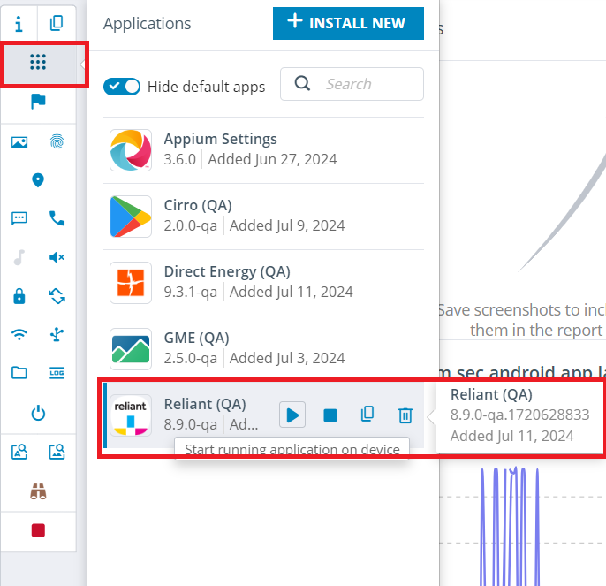

3)Check if Login screen appears in Dark mode

To find anyone’s Infomerica Email ID type name name in Search field

Always open Figma link of Bug/PBI not of Email

To Close Recently Opened App in iOS, pause after moving to middle of screen

To copy lengthy text from any app use Snipping Tool

If Ctrl-C is used to Stop script execution then device can be released as follows

While Creating Bug

1)Title should start with iOS/Android

2)Recheck if Build version is correct

To View all Automation Testcases under iOS PBI Click Links section

To Create a copy of Testcase select “Copy Testcase(s)” and add below data

VPN is to be connected to login to Jenkins

Full log is to be clicked in Console Output for all Steps display

If any changes are done by mistake pull your Branch using Github Desktop

Use Step Over shown in UI

22222 is a Valid Zip Code

Nextbee manages Reliant Rewards

Use Iphone XR(Dark Mode), Samsung S22 Ultra(Dark Mode) for Android and Iphone X for Automation testing

Shift+C clears Terminal

In Figma Hide UI by using Ctrl+\ and press H for Hand tool

To find a Method in all existing files use Edit-Find in Files

Postpaid Prepaid

View Bill Details View Balance Details

Webdriverio Version check-npx wdio --version